Emerging diversity: Designing inclusive group activities to stimulate inclusive environment for learning.
Positionality and context
I am a white Latvian with Russian-speaking background, I know what it’s like to speak the “wrong” language in my home-country. Which early on gave me an understanding of ethic and cultural prejudice. These experiences have instilled in me strong sense of social justice and the importance of intersectionality in my life and teaching practice. I was raised in a poor, single-mother household and brought up by strong women in my family, which I believe has shaped my worldview and made me more in tune with feminine perspectives. I identify as a cisgender heterosexual man, but I am often perceived as gay as I am “too feminine to be straight”. Which I actually find empowering, as many of my close friends are LGBTQ+ individuals and I’ve always been a strong ally. This perception has allowed me to connect more deeply with the LGBTQ+ community – broadening my understanding of gender and sexual diversity. Being perceived as part of this community has given me insights into the biases and misconceptions faced by LGBTQ+ individuals, strengthening my resolve to create safe and supportive spaces for all, both personally and professionally.
I was brought up as a Catholic, and I am familiar with Abrahamic beliefs and the benefits of close-knit communities and their dynamics. This background allows me to appreciate how faith shapes individuals and their worldviews. Over time, my own beliefs have shifted towards Zen Buddhism, influenced by my studies of Alan Watts(1999) and my appreciation for East Asian art and culture.
When I moved to the UK and did my GCSEs and A-Levels, I struggled immensely to engage with education due to language and cultural barriers. Although I had the passion, I was unable to communicate effectively, which led me to drop out of A-Levels, causing significant mental and family distress. Fortunately, I was able to refocus and study independently. Through my portfolio, I secured a job as a Graphic Designer, and with the encouragement of my colleagues, I decided to return to formal education. I enrolled in a BA in Games Design, where I finally felt part of a community and fully engaged with my education, ultimately earning my first honours degree.
After working in the games design industry, I experienced burnout and had a breakdown, which took me about a year and a half to recover from. This period of recovery was pivotal, as it redirected me back into education, where I pursued a Master's in Science in Programming for Video Games. I returned to the games design industry but eventually transitioned into academia, becoming a lecturer in games design. This career shift aligns better with my personality, allowing me to relate to and support struggling students, as I understand firsthand the challenges they face.
My background as a first-generation student, my journey through various educational and professional setbacks, and my identity as someone navigating multiple cultural and personal intersections all inform my commitment to fostering an inclusive and empathetic learning environment for my students, ensuring they feel supported and understood.
As a lecturer in immersion and interactive design at LCC, I focus on teaching Games Design and Virtual Reality, teaching across 3 cohorts. It is highly important to me that my students engage and collaborate with each other, as it promotes more unique and diverse ideas and it creates a healthy classroom culture. Currently we are experiencing growths of BAME students across UAL (figure 1).
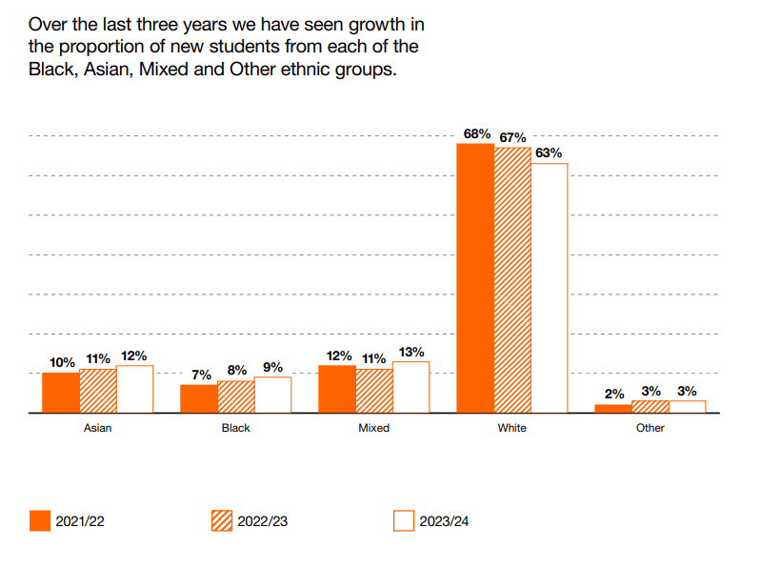
Figure 1 - Proportion of new students based on their background (UAL)

Based on the metrics from my courses (Figures 2 and 3), it's evident that the majority of my students are overseas students. Additionally, the proportion of students with declared disabilities is slightly higher (4%) than the college average (Figure 4). Although most students identify as areligious, there is a range of different religious beliefs represented, with Christianity being the most prevalent. Notably, 22% of students identify as LGBTQ+ (Figure 5). This data shows that my courses attract a diverse group of students with various backgrounds and needs, highlighting the importance of creating a learning environment that accommodates and supports these differences.
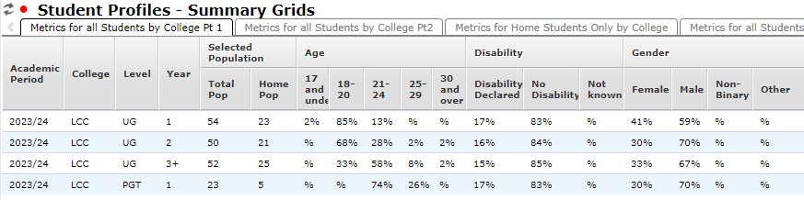
Figure 2 - Student Profiles Summary grid (LCC) BA Games Design, MA Games Design, MA VR (part 1)
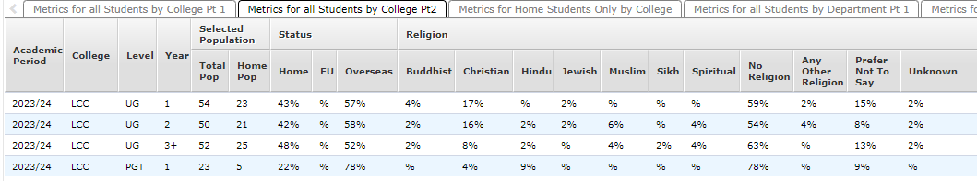
Figure 3 - Student Profiles Summary grid (LCC) BA Games Design, MA Games Design, MA VR (part 2)
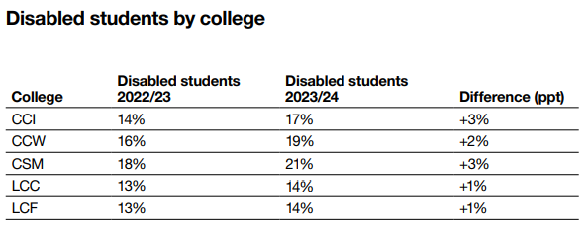
Figure 4- Disabled students by college
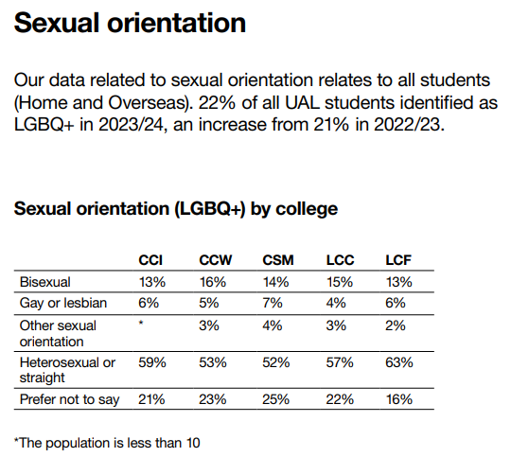
Figure 5- Sexual orientation per college
As our cohorts have grown from about 20 students to around 50 (see figure 2), it has become increasingly evident which groups may struggle with integration within the classroom or during group activities. Based on data and my own teaching experience, two groups stand out: students from Chinese-speaking regions and neurodivergent students. It's important to recognize that while these groups have distinct needs, they are not mutually exclusive, and some individuals may identify with both. Addressing their integration challenges requires a nuanced understanding of their unique and sometimes overlapping experiences. It seems fitting to explore this challenge via Kimberle Crenshaw’s (1989) theory of intersectionality as it directly analyses nature of discrimination or privilege, helping me to identify areas of potential improvements. The next 2 paragraphs explain the nature of these 2 groups based on my research and personal experience.
What is visible is that students from similar backgrounds – notably students from Chinese speaking regions- tend to stick together and stay in the similar social groups because of their immediate lingual familiarity. This may be comfortable at first, but later on it can be very difficult to mix those groups of students with the rest of the class as they have already established cliques, and they are unwilling to work with others because this is the established classroom culture that worked thus far- which is understandable – but is limiting in the long run. I have reached this conclusion from questionnaire (Appendix 2 |response 4.3), as well as my personal teaching experience – we had a few situations where Chinese- speaking students have refused to work with students from other backgrounds. Please see full breakdown of the questionnaire in the Appendix 3.
When discussing neurodivergent individuals, it's important to recognize that not all of them experience shyness or difficulty communicating with others, and sometimes their neurodivergence is completely invisible unless they choose to disclose it. This diversity of experiences means that assumptions about their needs and behaviours should be avoided, as each individual's experience is unique. That being said, for those neurodivergent individuals who do seek support, many tend to prefer structured environments and clear, literal explanations. This can help reduce ambiguity and anxiety, allowing them to engage more comfortably, this is reflected in the Autism Speaks (2018) – School community toolkit as well as the response from the questionnaire (Appendix 2 |response 4.5), and in my experience – students with autism, can often overcome social anxiety, when they are constantly, guided and when the outcome of the collaboration is made abundantly clear to them.
Intervention and implementation techniques
When I was reflecting on Asif Sadiq’s (2023) TED talk about Diversity, Equity and Inclusion, there was this one point that sparked my interest. He advocates that diversity should not be global, but instead it should be hyper localised – focussing on the particular group of people and trying to understand different cultures and perspectives, respecting differences and working towards more inclusive goals. I have immediately remembered reading Steven Johnson’s (2002) book about emergence, and how cities, cultures and cells self-organise in a natural diverse way, and the main principle mirrors Asif Sadiq’s view.
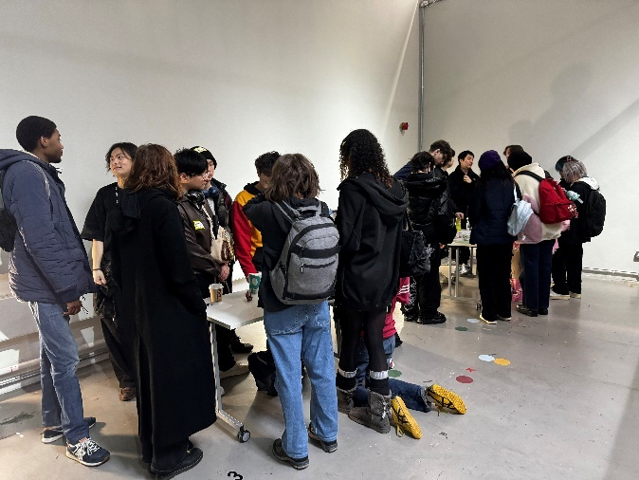 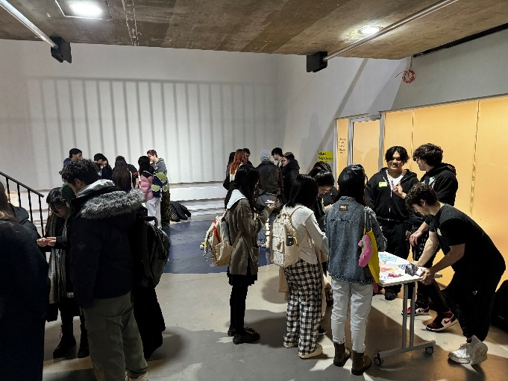
(I took some pictures of my students participating in an ice-breaker activity, this is the first time Games Design students and Games Arts students meet each other – I provide little activities on each table such as origami or drawing challenge, and students can only spend 10 minutes per activity, and then one cohort of students rotates to the next table – all of the students tend to engage with this activity)
The intervention that I am designing is a scaffolding for student icebreakers and other group activities that promote inclusivity and cooperation informed by natural systems as opposed to man-made systems. There are several fundamental principles that promote macro-intelligence and adaptability which derive from local knowledge and local interactions.(See appendix 1) I am applying these rules in the context of group exercises, it’s important to understand that not all rules need to be followed as a lot of them are self-referential and do not always align with a particular course’s curriculum, however these rules should encourage diversity and inclusivity.
Reflection and feedback
Feedback from the questionnaire suggests that, in general, students enjoy participating in group activities regardless of their backgrounds. However, difficulties arise when activities are unclear, disconnected, don't align with their interests, or lack structure—in these cases, individuals tend to gravitate towards familiar peers for comfort, which is understandable. A recurring suggestion was to offer a wider variety of activities to better match individual interests. It's also important to provide clear instructions to accommodate different needs, particularly for neurodivergent students. The feedback highlights the need to balance structure with flexibility, giving students the space to engage comfortably while encouraging them to step outside their usual groups. Overall, the feedback reinforces the effectiveness of the approach, though ongoing adjustments and changes are necessary to suit the unique dynamics of each student group. It's clear that students want to participate in group activities and learn about others, and it's crucial to create inclusive environments that support these goals.
Conclusion
Based on reflections and feedback from peers, alumni, and students, it is evident that inclusive group activities play a significant role in enhancing engagement and creating a more inclusive learning environment. Many participants aligned with the principles outlined in my approach, reinforcing its effectiveness and viability. Drawing from my experience in Games Design and my understanding of intersectionality, I am confident that there are clear strategies that can promote engagement when approached with empathy and openness.
While my approach may not address every individual preference—such as those who prefer working independently—it offers a supportive framework for creating engaging activities that inspire creative thinking and mutual understanding. It is essential to continuously adapt and refine these strategies to ensure that all students feel valued and empowered, recognizing that their unique perspectives contribute to a richer and more inclusive educational experience for everyone.

References:
Sadiq, A. (2023) Diversity, Equity & Inclusion. Learning how to get it right. TEDx [Online. Available at: https://www.youtube.com/watch?v=HR4wz1b54hw }. [Accessed, September, 08, 2024]
Johnson, S. (2002). Emergence : the connected lives of ants, brains, cities and software. London: Penguin.
Watts, A. (1999). The Way of Zen. ,A Division of Penguin Random House LLC. New York: Random House Inc
Crenshaw, K. (1989) Demarginalizing the Intersection of Race and Sex: A Black Feminist Critique of Antidiscrimination Doctrine, Feminist Theory and Antiracist Politics. In University of Chicago Legal Forum. (1989 1:8)
Autism Speaks (2018). Autism in the classroom: Strategies for success. [online] Autism Speaks. Available at: https://www.autismspeaks.org/tool-kit-excerpt/autism-classroom-strategies. [Accessed, September, 08 ,2024]
Figures:
Figure 1, Proportion of new students based on their background (UAL) – Equality, Diversity and Inclusivity – Annual repoty 2022/23 Available at: https://www.arts.ac.uk/__data/assets/pdf_file/0015/432141/SPCB23435-EDI-report-2022-23.pdf
[accessed September, 08, 2024]
Figure 2, - Student Profiles Summary grid (LCC) BA Games Design, MA Games Design, MA VR (part 1) UAL – Dashboard data. Student Profiles – Summary Grids. Available at: https://dashboards.arts.ac.uk/
[accessed September, 08, 2024]
Figure 3, - Student Profiles Summary grid (LCC) BA Games Design, MA Games Design, MA VR (part 2) UAL – Dashboard data. Student Profiles – Summary Grids. Available at: https://dashboards.arts.ac.uk/
[accessed September, 08, 2024]
Figure 4,Disabled students by college (UAL) – Equality, Diversity and Inclusivity – Annual repoty 2022/23 Available at: https://www.arts.ac.uk/__data/assets/pdf_file/0015/432141/SPCB23435-EDI-report-2022-23.pdf [accessed September, 08, 2024]
Figure 5, Sexual orientation (UAL) – Equality, Diversity and Inclusivity – Annual repoty 2022/23 Available at: https://www.arts.ac.uk/__data/assets/pdf_file/0015/432141/SPCB23435-EDI-report-2022-23.pdf [accessed September, 08, 2024]

Appendix 1: Scaffolding for group activities
It is important to acknowledge that these principles are nature-inspired, encouraging natural engagement by emulating the adaptability and resilience found in natural systems on multiple levels. While not all rules need to be strictly followed, incorporating as many of them as possible when designing group activities for students can lead to more inclusive and effective outcomes.
1) Simple rules lead to complex behaviours – Design activities that are simple and self-contained
with only a few rules. This simplicity ensures that everyone can easily follow along, and it encourages natural communication and efficiency among participants. Simple instructions can lead to unexpectedly rich and complex interactions. Additionally, simple instructions greatly assist neurodivergent individuals by reducing ambiguity and making participation more accessible and less overwhelming.
2) Local interactions – Foster environments where behaviours emerge from interactions at a local level rather than being dictated by a top-down approach. This means allowing students the freedom to engage creatively and explore ideas in an unscripted way, which can lead to organic collaboration and innovation.
3) Bottom-up organisation – Extend the idea of local interactions by emphasizing a decentralized structure. Encourage students to take initiative in proposing extra-curricular activities, like board game nights or other social events, allowing them to shape their own engagement and community dynamics.
4) Feedback loops: Implement mechanisms for feedback that reinforce positive behaviours and help adjust negative ones. In group activities, this can involve highlighting cooperative behaviours, providing constructive feedback, and ensuring that all voices are acknowledged. Feedback loops help in reinforcing what works well and adjusting what doesn’t.
5) Adaptation and learning: Promote activities that expose students to a variety of experiences, encouraging them to adapt and learn. This principle suggests that by regularly introducing new activities, students can develop better communication skills and adaptability, enhancing their overall engagement and learning efficiency.
6) Pattern formation: Design activities that are open-ended to foster spontaneous interactions among students. Repeating the same exercises can lead to predictable outcomes; therefore, varying the types of activities helps maintain a dynamic and engaging environment.
7) Decentralisation: Distributing tasks among students allows them to manage their work together. This builds autonomy, responsibility, and helps students rely on each other, creating a more inclusive and cooperative group.
8) Self-organisation: Trust students to naturally organize themselves within group exercises. Allowing them to take the lead in structuring their activities can enhance their sense of responsibility and ownership, leading to more genuine engagement.
9) Scalability: The principles that work on a small scale can often be applied to larger settings. For example, group activities designed for small teams can be adapted for entire classes, maintaining the same foundational principles. This adaptability ensures that inclusive practices are maintained regardless of group size or complexity.

Appendix 2: Questionnaire Results
Question 1:
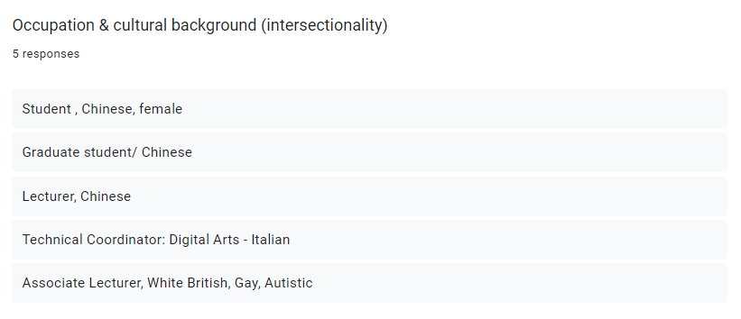
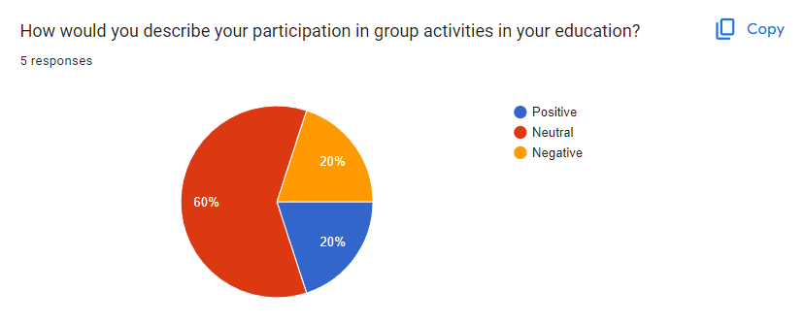
Question 2:
Question 3:
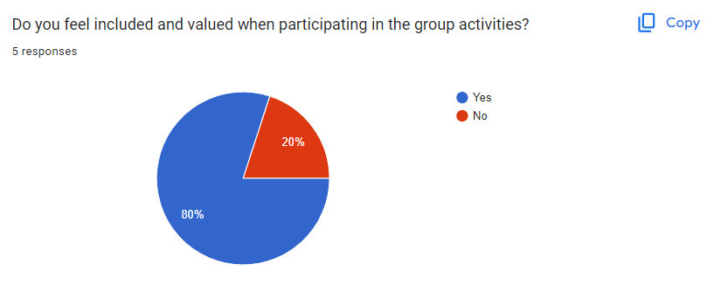
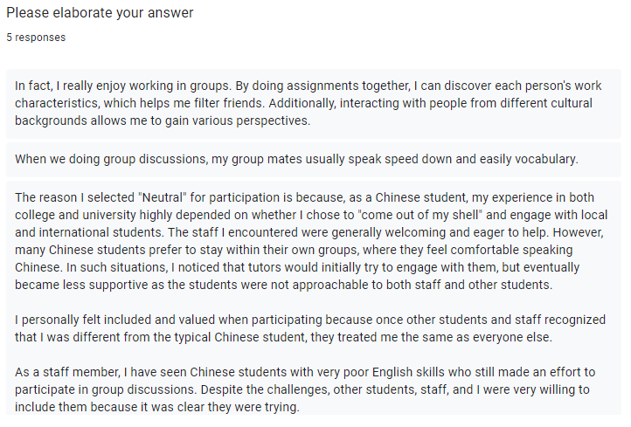
Question 4:
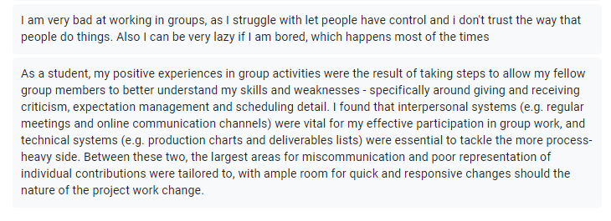
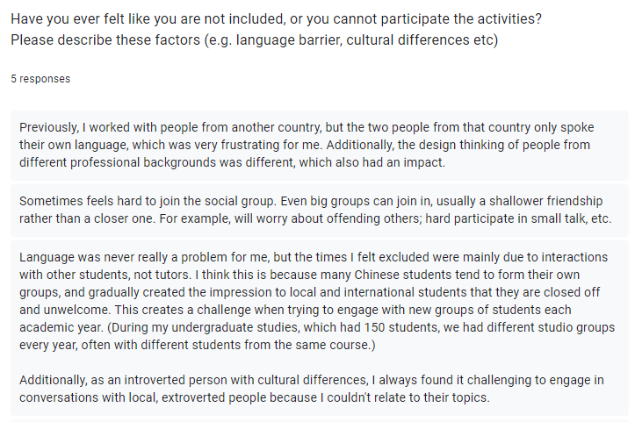
Question 5:
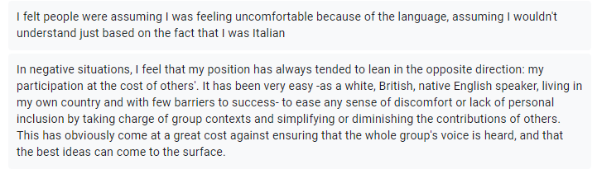
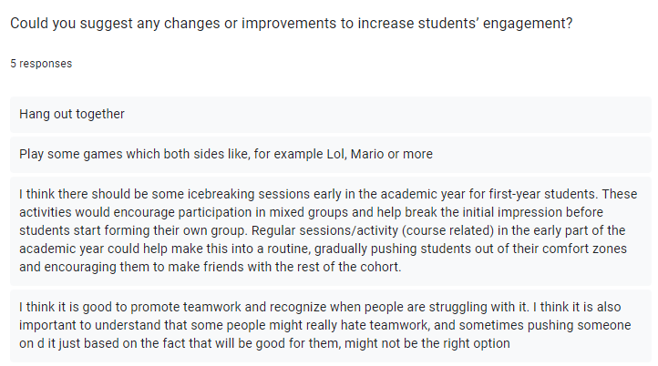
Question 6:
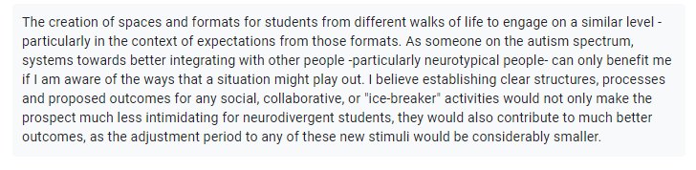
Question 7:
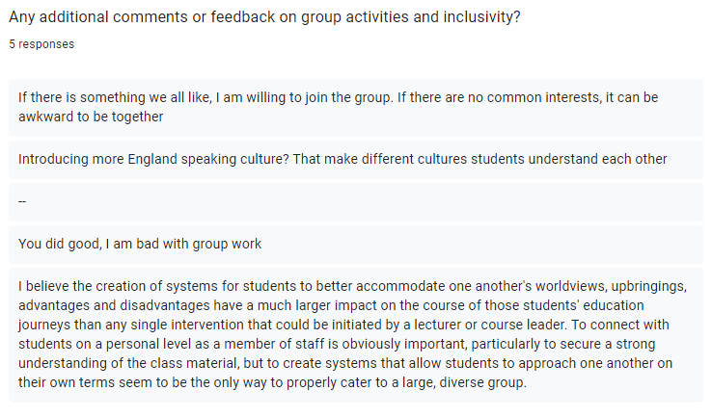

Appendix 3: Questionnaire analysis
As part of my research and reflection I have had conversations with my peers and alumni about inclusivity in the classroom and how the class activities can promote diversity and avoid formations of cliques. To support that I have also created a Google form, where the participants were given 7 simple questions addressing their view and positionality on the participating in group activities. To get a diverse range of answers I have interviewed a group of people with different identities and positionalities. These include: an alumnus of the course, a student from a different university, academic support, technical coordinator and other lecturers. Following my conversations and the answers from the questionnaire, I will sum them up in the context of my intervention. I found that evaluating intersectionality is often more effective through qualitative methods, as they provide deeper insights into individual experiences and complexities that quantitative data alone may not capture. Below, I summarize key responses from the questionnaire: (Please see Appendix 2 for more details)
Question 1: Occupation or Cultural background (Intersectionality)
This question demonstrates the variety of people that have participates in this questionnaire, reflecting their broad spectrum of perspectives and experiences.
Question 2: How would describe your participation in group activities in your education?
60% of people describe their experience in group activities as neutral, while the remaining 40% are evenly split between positive and negative experiences, which implies a varied response that suggests room for improvement in making these activities more engaging and inclusive for everyone.
Question 3/4: Do you feel included and valued when participating in the group activities?
Question 3 serves as a lead-up to Question 4, revealing that 80% of students feel valued when participating in group activities, indicating a generally positive perception of inclusivity and engagement within these settings.
The majority of participants shared that working in diverse groups can be empowering, as it brings together different perspectives and encourages collaboration. Many felt that their peers were understanding and accommodating, particularly when it came to language differences, which made them feel included. One respondent appreciated the chance to learn about different work styles and cultural backgrounds, which helped them connect with others and broaden their view.
However, not all experiences were positive. Some individuals, especially those who have difficulty trusting others' methods or prefer to keep control over tasks, found group work challenging and often disengaging. This feedback suggests that while group activities can be beneficial, they are not suited to everyone, and some students may prefer working alone. It's important for educators to design group activities thoughtfully, making sure they are inclusive and accessible for all students, and to recognize that the main goal of group work is often about participation and connection, rather than just the end result.

Question 5: Have you ever felt like you are not included, or you cannot participate the activities?
Please describe these factors (e.g. language barrier, cultural differences etc)

The responses to this question reveal several common challenges, with many negative experiences stemming from assumptions and a lack of effort to understand one another. Issues ranged from language barriers and cultural differences to introversion and social anxiety. For example, some respondents felt excluded when others spoke in languages they didn’t understand or when they couldn’t connect on a deeper level due to differing social norms. Others mentioned that assumptions about their language abilities or cultural background made them feel misunderstood or isolated.
These insights highlight the importance of creating opportunities for all students to participate in class and extracurricular activities from the outset. Early and consistent engagement can help prevent the formation of cliques and reduce misconceptions. It's crucial to design activities that encourage everyone to interact, share their perspectives, and build connections over time. This approach can help students better understand each other’s worldviews and create a more inclusive and supportive environment where everyone feels valued and heard.
Question 6: Could you suggest any changes or improvements to increase students’ engagement?
The responses to this question were pretty straightforward: students want to hang out and play games together, which can be an easy way for them to connect. However, some responses also suggested having icebreaker sessions early in the academic year, especially for first-year students, to encourage them to mix and interact before cliques form. Regular sessions or activities, particularly early on, could help make interacting in mixed groups a normal part of the routine.
There was also a recognition that not everyone enjoys teamwork, and it's important to be mindful of this—pushing someone into group work just because it's “good for them” might not always be the right approach. For neurodivergent students, having clear instructions, structures, and goals for any group or social activities can make these experiences less overwhelming and more manageable.
To keep things engaging and help students find common ground, it might be useful to have different themes or activities every few weeks, like video game nights, origami, or storytelling sessions. This can help create more opportunities for students to connect over shared interests in a relaxed and open environment.

Question 7: Suggestions?
Based on the responses, it seems clear that students prefer engaging in activities where they share common interests, as this helps reduce awkwardness and makes group interactions more comfortable. There was also a suggestion to introduce more English-speaking cultural elements to help bridge gaps between students from different backgrounds, which aligns with the principle of adaptation and learning by encouraging cultural exchange and understanding.
One response highlighted the importance of creating systems that allow students to connect with each other on their own terms, suggesting that meaningful interactions among students are more impactful than any single intervention from a lecturer. This reflects a broader desire for group activities that are inclusive and responsive to the diverse needs and backgrounds of all students, fostering a more organically inclusive environment.

